College of Computing & Informatics (CCI)
SENIOR PROJECT-I REPORT
NFC-AI: Smart Shopping Assistant

Author(s):
#220049974 Hassan AlHassan
#220022953 Khalid AlHelal
#220023658 Ibrahim AlSayah
#220032220 Mohammed AlHajjiAhmed
#220004416 Ali AlQadhib

Project Supervisor:
Dr. Moner Alsader

NFC-AI: Smart Shopping Assistant
By:
Hassan Al Hassan.
Khalid AlHelal.
Ibrahim AlSayah.
Mohammed AlHajjiAhmed.
Ali AlQadhib.

Thesis/Project submitted to:
College of Computing & Informatics, Saudi Electronic University, Riyadh, Saudi Arabia.

In partial fulfillment of the requirements for the degree of:
BACHELOR OF SCIENCE IN COMPUTER SCIENCE
Project Supervisor |  | Project Committee Chair

ABSTRACT
This project, NFC-AI: Near Field Communication (NFC) and artificial intelligence (AI) combined to create a Smart shopping assistant. It lets smartphone owners scan a product's NFC tag to get product information including ingredients, nutritional values and allergen details. More inclusively, the app includes text-to-speech functionality so visually impaired users and those struggling with reading can hear the product details instead of just visual labels.

The core contribution here is the integration of an AI module that suggests healthier or allergy-safe alternatives based on the scanned product information. This is for all users, but it is especially useful for visually impaired or dietary-restricted people to shop confidently.

Working on it has helped us develop skills in mobile application development (Android/Kotlin), data management, and practical usage of AI APIs. It also provided experience in designing assistive technology for real-world accessibility challenges, balancing technical learning goals with social impact.

DEDICATION
This work is dedicated to:

Our Family - for all the love, patience & support throughout our studies.

Our Friends - for encouraging us to keep going.

Our Project Advisor Dr. Moner Alsader - for his advice, feedback and encouragement along the way.

Without their assistance this wouldn't have happened.

PREFACE
In this report, we report on the first phase of our graduation project NFC-AI: Smart Shopping Assistant. The aim of this work is to find out and prepare a practical solution to shopping difficulties faced by visually impaired users and dietary restrictions and allergic people. Near Field Communication (NFC) and Artificial Intelligence (AI) combined in one project will allow easy access to product information as well as personalized alternatives for everyone.

Clarify that this Senior project involves research, requirement analysis, design planning, and documentation. Implementation and full development of this app will be in Senior Project 2

We thank our advisor Dr. Moner Alsader for his advice and support throughout this stage of the project. We also acknowledge Saudi Electronic University for providing us with the academic environment and resources to carry out this work.
REVISION HISTORY
Name | Date | Reason For Changes | Version

TABLE OF CONTENTS

CHAPTER 1: INTRODUCTION 7
1.1 Project Background/Overview: 7
1.2 Problem Description: 7
1.3 Project Scope: 7
1.4 Project Objectives: 8
1.5 Project Structure/Plan: 9
CHAPTER 2: LITERATURE REVIEW 11
CHAPTER 3: METHODOLOGY 15
CHAPTER 4: SYSTEM ANALYSIS 16
4.1 Product Features: 17
4.2 Functional Requirements: 17
4.3 Nonfunctional Requirements 22
4.4 Analysis Models 23
CHAPTER 5: SYSTEM DESIGN 24
CHAPTER 6: DISCUSSION & CONCLUSION 27
6.1 Discussion 31
6.2 Conclusion 32
REFERENCES 33
APPENDIX: Glossary 35

CHAPTER 1: INTRODUCTION
  - Project Background/Overview:

This project focuses on designing a mobile application concept that integrates Near Field Communication (NFC) with Artificial Intelligence (AI) to provide accessible and intelligent shopping support. The system is intended to read NFC tag data from products, retrieve stored details such as ingredients, nutritional values, and allergens, and use text-to-speech (TTS) to make this information accessible for users who cannot easily read packaging. In addition, AI will be employed to suggest healthier or allergy-safe alternatives, enabling shoppers to make more informed choices.

  - Problem Description:

Product packaging in supermarkets often presents accessibility challenges. Visually impaired individuals find it difficult to read small print or complex labels, while other shoppers may struggle to quickly compare nutritional values or allergen warnings between products. This lack of immediate, clear information can hinder safe and efficient shopping.

The underlying problem is the absence of a solution that provides fast, accessible, and intelligent access to product information inside supermarkets.

  - Project Scope:

The scope of this project is limited to the research, analysis, and design of a smart shopping assistant system. Rather than a commercial product, it is a conceptual framework supported by prior research and structured planning. The focus is on:
- Defining the requirements of a system that enables NFC tag scanning to retrieve product details.
- Designing an accessibility layer using text-to-speech for real-time audio output.
- Outlining a local product database structure (JSON or database form).
- Exploring AI-based mechanisms for suggesting healthier or allergy-safe alternatives.

  - Project Objectives:
The main objectives are:
- To conduct research and define the requirements for an NFC- and AI-powered shopping assistant.
- To design a system architecture that integrates NFC scanning, text-to-speech, AI recommendations, and a product database.
- To analyze and document accessibility features that support visually impaired and health-conscious users.
- To explore AI methods that can generate dietary-safe or healthier product alternatives.
- To develop project documentation and planning materials that form the foundation for potential implementation in the future.

  - Project Structure/Plan:

1. Project Initiation & Team Formation (Week 1)
This was the start of the project after selecting the idea “NFC-AI Smart Shopping Assistant.” Team roles were assigned, responsibilities defined, and the leader was named. The team collaboratively defined the problem statement, project scope, and objectives.

2. Research and Literature Review (Weeks 2–3)
Prior work on NFC-based mobile applications, AI-powered recommendation systems, and accessibility tools for visually impaired users was reviewed critically. This activity revealed existing gaps and provided a strong foundation for the proposed solution.

3. Requirement Gathering and Analysis (Weeks 3–4)
Functional and non-functional requirements were identified. Functional requirements include NFC scanning, text-to-speech output, and AI-based product alternatives. Non-functional requirements focus on performance, usability, and security. This phase clarified what the system must achieve and under what constraints it should operate.

4. System Design & Planning (Weeks 4–9)
The team is currently in the system design phase, preparing the overall system architecture, use-case diagrams, ERD, and class diagrams. This phase also involves developing the Gantt chart and ADM/PDM diagrams, which define the project’s workflow and timeline.

5. Documentation & Refinement (Weeks 9–11)
All research, requirements, and design work are compiled and structured into the final documentation. Feedback is reviewed and refinements are made to ensure completeness and clarity.

6. Final Submission & Presentation (Weeks 11–12)
The final stage focuses on preparing the presentation, finalizing documentation, and submitting the complete project to meet the academic requirements.
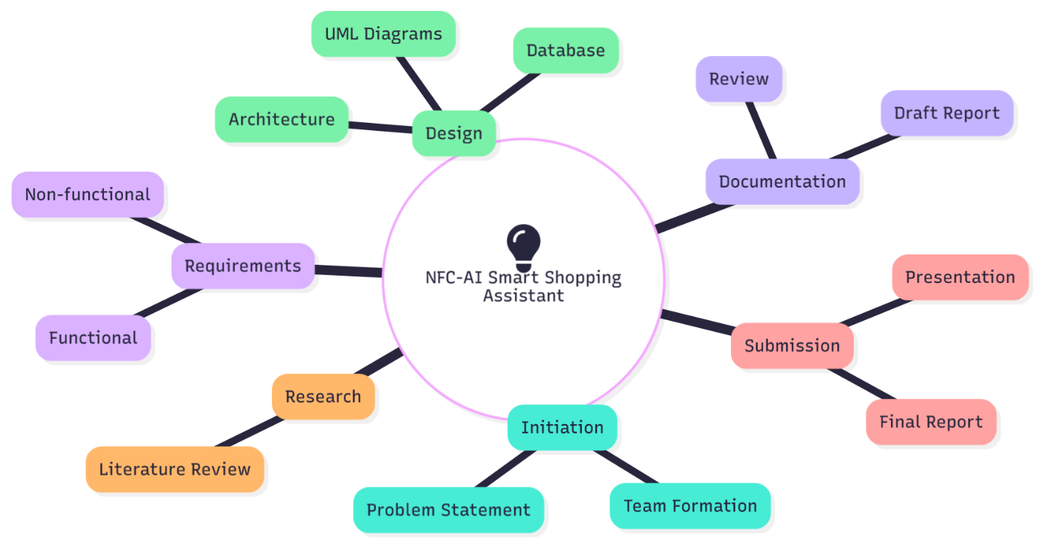
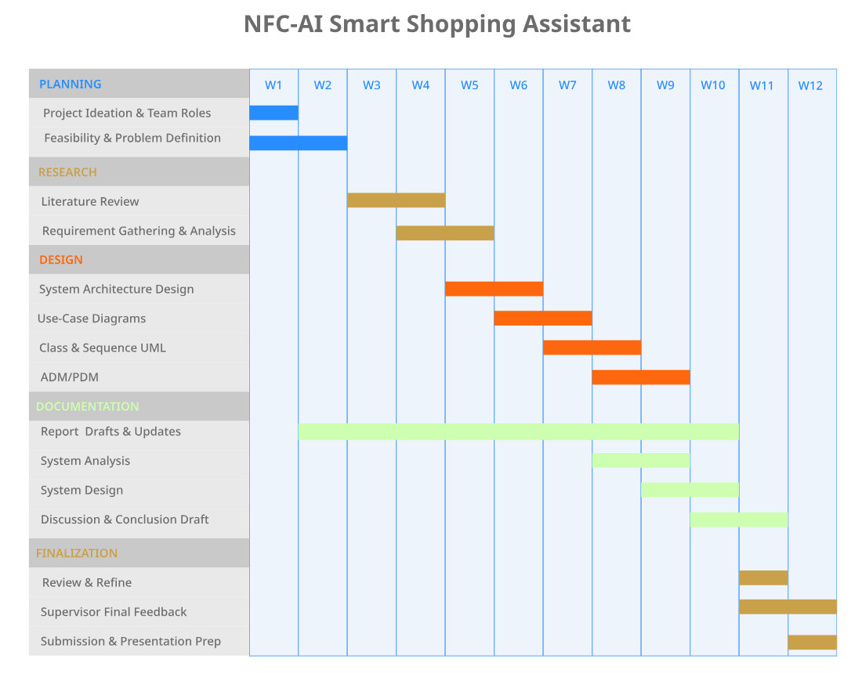
Gantt Chart
Mind Map

CHAPTER 2: LITERATURE REVIEW

2.1 Accessibility in Shopping Technologies
Several studies have examined the role of technology in supporting visually impaired or disabled consumers in shopping environments. Kamikubo et al. (2024) described the challenges blind users face during recreational shopping, emphasizing the absence of systems that provide real-time product information. While insightful, their study remained descriptive and lacked a concrete technological solution. Filippini et al. (2024) investigated assistive technologies for blindness and low vision, identifying NFC tagging as a promising method for object recognition. However, their focus was primarily on recognition rather than integration with broader retail systems. Lavric et al. (2024) similarly surveyed emerging assistive technologies and found NFC to be lightweight and effective, though their work did not explore personalization or user-specific recommendations.
Gap Identified: Existing research addresses accessibility but does not provide a unified system combining object recognition, personalized guidance, and real-time feedback during shopping.
Our Solution: The NFC-AI Smart Shopping Assistant fills this gap by using NFC tags for immediate product detection, followed by AI-generated dietary alternatives and text-to-speech output to support visually impaired and blind users with both accessibility and decision-making during physical shopping.

2.2 AI-Powered Recommendations for Health and Safety
Nutrition and dietary recommendation systems have emerged as an important research area. Letaifa et al. (2023) demonstrated that natural-language justifications improve trust in nutrition recommenders. Rostami et al. (2023) proposed a time-aware food recommender, but their system was designed as a stand-alone app rather than being integrated into physical retail environments. Zioutos et al. (2023) and Lee et al. (2025) showed that personalized dietary recommendations help users with dietary restrictions, yet their implementations remained digital-only. These works highlight the value of AI-driven nutrition support but do not address the needs of in-store shoppers who require instant, contextual recommendations.
Gap Identified: Prior recommenders operate in digital environments and lack real-time product scanning, physical-store integration, or accessibility features.
Our Solution: The NFC-AI Smart Shopping Assistant embeds AI dietary recommendations directly into the product-scanning workflow, providing instant alternative suggestions, health guidance, and spoken explanations immediately after tapping an NFC tag in a real store.

2.3 Voice and Multimodal Interfaces
Voice-based interaction has been shown to improve inclusivity and engagement in digital retail. Calahorra-Candao et al. (2024) reported high acceptance of voice shopping technologies. Mo et al. (2024) further emphasized that personalization and responsiveness in voice assistants directly influence user satisfaction. Similarly, Messi et al. (2025) and Jakob et al. (2025) validated that adaptive audio interfaces simplify complex tasks for visually impaired and older adults. However, these findings have not been directly applied to NFC-enabled physical retail environments.
Gap Identified: Voice interfaces exist but are not integrated with NFC-based product identification or in-store dietary guidance.
Our Solution: The NFC-AI Smart Shopping Assistant provides instant text-to-speech feedback after every scan, delivering product details, allergen warnings, and healthier alternatives. This allows visually impaired users to shop independently without relying on visual screens or external assistance.

2.4 NFC and Smart Retail Applications
NFC technology has become central in smart retail. Yu et al. (2023) showed that NFC payments improve trust and usability. Žurbi et al. (2024) demonstrated NFC-enabled packaging for delivering digital product information. Pires et al. (2024) explored NFC-based supermarket simulations for people with disabilities, confirming its value for inclusive retail. Zhang et al. (2025) highlighted NFC’s versatility across retail applications. Despite these advances, NFC is mostly used for payments or static product descriptions, not for intelligent or personalized recommendations.
Gap Identified: No existing work combines NFC product scanning with AI-powered recommendations and accessibility-focused voice interaction into one system.
Our Solution: The NFC-AI Smart Shopping Assistant uses NFC tags as the entry point to a full decision-support system, transforming basic product identification into a personalized, health-aware, accessibility-driven shopping companion.

2.5 Security and Reliability Considerations
Onumadu et al. (2024) examined NFC-related cyber threats such as eavesdropping, tag cloning, and data tampering, proposing mitigation strategies for secure communication. While valuable, their work does not address NFC use in assistive retail systems or the privacy needs of vulnerable users.
Gap Identified: Prior work focuses on security in payment systems, not on safeguarding assistive NFC-based shopping solutions where user safety and privacy are critical.
Our Solution: The NFC-AI Smart Shopping Assistant incorporates local data handling, secure tag associations, and limited exposure of personal preferences, ensuring a safe and privacy-conscious experience for users—particularly visually impaired shoppers who rely on accurate and trustworthy NFC interactions.

However, certain misuses or technical issues may still arise, such as users receiving incorrect product information, or NFC tags being tampered with or replaced by attackers with malicious tags. Lower-risk data exposures may also occur if temporary usage logs or basic preference settings are accessed on an unsecured device.
Our application mitigates these concerns by verifying each scanned tag against a securely stored product ID, locking tags to prevent unauthorized rewriting, and encrypting all user data and local logs, ensuring that both intentional manipulation and accidental misuse are detected and minimized.

2.6 Research Gap and Contribution Identified
The reviewed literature demonstrates progress across accessibility (Filippini et al., 2024), AI dietary recommendations (Rostami et al., 2023), and NFC-enabled retail applications (Žurbi et al., 2024; Pires et al., 2024). However, these contributions remain isolated, with no existing solution combining NFC product identification, AI-powered nutrition support, and voice-based accessibility into a unified system.
Our Contribution:
The NFC-AI Smart Shopping Assistant integrates all three components—NFC object detection, AI-driven dietary guidance, and accessibility-focused text-to-speech—into a single mobile tool. This unified approach addresses gaps in the current literature by providing:
- Real-time support for visually impaired users
- Personalized health recommendations during physical shopping
- An intelligent assistant that bridges the gap between digital and in-store retail experiences
This contribution represents a meaningful step toward inclusive smart retail solutions.

CHAPTER 3: METHODOLOGY
3.1 Introduction
The methodology defines how the NFC-AI Smart Shopping Assistant project will be planned, developed, and delivered. Since the project involves integrating multiple technologies — NFC, AI recommendation, and Text-to-Speech accessibility — it requires a structured yet flexible software development approach. The team selected the Agile (Incremental Development) methodology to allow iterative progress, adaptability, and efficient task management across the semester timeline.

3.2 Selected Methodology: Agile (Incremental Development)
The Agile methodology emphasizes flexibility, collaboration, and iterative development. Instead of building the entire application at once, the system is developed in small, functional increments. Each increment focuses on delivering specific features, such as NFC scanning, TTS integration, or AI recommendations, which can be reviewed, tested, and refined before moving to the next stage.
This method suits the project because:
- It aligns well with the 12-week academic schedule.
- It allows early testing and feedback.
- It supports evolving the system design as new insights arise.
- It encourages collaboration between the Leader and Team Members.

3.3 Rationale for Choosing Agile
Reason | Benefit for Project
Iterative & Flexible | Allows adding or refining NFC, TTS, and AI modules progressively.
Early Testing & Feedback | Each module can be tested upon completion, reducing bugs later.
Team Collaboration | The leader and team members contribute equally throughout each sprint.
Time-Boxed Development | Sprints align perfectly with the weekly academic structure (W1–W12).
Risk Reduction | Complex modules (like AI integration) can be addressed early and improved incrementally.

3.4 Development Phases under Agile
Phase | Description | Output
1. Planning & Initiation | Define project scope, team roles, feasibility, and overall vision. | Project charter, timeline.
2. Requirements Gathering | Identify functional (NFC, TTS, AI) and non-functional requirements. | Requirements specification document.
3. System Design & Prototyping | Design system architecture, UML diagrams, ERD, and user interaction flows. | UML models, ER diagrams, architecture draft.
4. Incremental Development | Build modules in sprints (e.g., NFC → TTS → AI). Each sprint ends with testing and review. | Working system components.
5. Testing & Refinement | Validate functionality, fix issues, ensure accessibility and performance. | Test reports, refined software.
6. Documentation & Submission | Compile documentation, finalize presentation, and prepare the final deliverable. | Final report and presentation.
3.5 Sprint Planning Strategy
The 12-week timeline is divided into four sprints:
Sprint | Weeks | Focus | Deliverable
1 | W1–W3 | Planning, research, requirements, NFC prototype | Initial architecture & NFC functionality
2 | W4–W7 | Text-to-Speech module + UI integration | Functional NFC + TTS
3 | W8–W10 | AI recommendation engine integration | Working AI module
4 | W11–W12 | Testing, refinement, documentation, presentation | Finalize system architecture, UI design, UML diagrams, and documentation

3.6 Tools and Technologies
Category | Tools / Technologies Used
Development | Android Studio (Kotlin/Java), NFC Android APIs
AI Integration | AI API (Recommendation System)
Accessibility | Android Text-to-Speech (TTS)
Collaboration | GitHub, Trello, Notion
Design & Diagrams | Lucidchart, Draw.io, UML tools
Documentation | Microsoft Word, MS Project (Gantt)

CHAPTER 4: SYSTEM ANALYSIS

  - Product Features:
Feature | Description | Priority
NFC Product Scanning | The user can scan NFC tags on products to instantly retrieve product details such as name, ingredients, allergens, etc. | High
Text-to-Speech Accessibility | The system reads product information aloud to support visually impaired users. | High
AI Product Recommendations | The system suggests healthier or allergy-safe product alternatives using an AI model. | High
Product Information Display | Displays product details in a clear, structured, and accessible user interface. | High
Local/Cloud Data Access | Fetches product data from a local or cloud database for faster and accurate retrieval. | Medium
Accessibility Settings | Allows users to enable or disable TTS and change language or audio preferences. | Low
User Interaction Logging | Logs product scans and interactions to improve recommendations over time. | Medium
The NFC-AI Smart Shopping Assistant is designed to enhance the shopping experience by providing accessible and personalized product information. The main product features are:

  - Functional Requirements:
Based on the product features, the following functional requirements are identified:
ID | Functional Requirement | Related Feature | Priority
FR1 | The system shall allow the user to scan NFC tags and retrieve product information. | NFC Product Scanning | High
FR2 | The system shall read the product information aloud using TTS. | Text-to-Speech Accessibility | High
FR3 | The system shall suggest alternative products based on the scanned product’s data. | AI Product Recommendations | High
FR4 | The system shall display product information clearly and accessibly. | Product Information Display | High
FR5 | The system shall fetch product data from the database. | Local/Cloud Data Access | Medium
FR6 | The system shall allow users to adjust accessibility settings. | Accessibility Settings | Low
FR7 | The system shall log user interactions for future analysis. | User Interaction Logging | Medium

Use Case: Scan Product via NFC
Field | Description
Identifier | UC-1
Purpose | Allow the user to scan a product’s NFC tag and retrieve its details.
Priority | High
Pre-conditions | NFC enabled, app running.
Post-conditions | Product information is displayed and read aloud.
Typical Course of Action
S# | Actor Action | System Response
1 | User brings device near NFC tag. | System detects tag.
2 | User holds device steadily. | System reads product information.
3 | - | Product information is displayed and read aloud via TTS.
Alternate Course of Action
S# | Actor Action | System Response
1 | User scans invalid or unreadable tag. | System shows error message and prompts re-scan.
2 | User retries scan. | System reads product successfully and proceeds normally.

Use Case: Get Product Recommendations
Field | Description
Identifier | UC-2
Purpose | Provide AI-based recommendations for healthier or allergy-safe alternative products.
Priority | High
Pre-conditions | Product data retrieved from NFC scan.
Post-conditions | Alternative products displayed or read aloud.
Typical Course of Action
S# | Actor Action | System Response
1 | User scans a product or selects one from history. | System processes product data.
2 | - | AI engine analyzes and finds alternatives.
3 | - | System displays and reads recommended products.
Alternate Course of Action
S# | Actor Action | System Response
1 | User scans a product not found in the database. | System displays “No recommendations found.”
2 | User selects another product. | System generates recommendations successfully.

Use Case: Enable Text-to-Speech
Field | Description
Identifier | UC-3
Purpose | Allow the system to read product information aloud for accessibility.
Priority | High
Pre-conditions | Product details are displayed.
Post-conditions | Product details are read aloud.
Typical Course of Action
S# | Actor Action | System Response
1 | User scans or selects a product. | System activates TTS.
2 | - | System reads product details aloud.
Alternate Course of Action
S# | Actor Action | System Response
1 | User has TTS disabled. | System prompts the user to enable TTS in settings.
2 | User enables TTS. | System reads the product details aloud.

  - Nonfunctional Requirements

- Performance Requirements
The system must provide real-time feedback to users to maintain a smooth shopping experience.
- NFC scan response time: less than 2 seconds after tapping the tag.
- AI recommendation generation: under 4 seconds from scan to display.
- TTS response: speech output starts within 1 second after the product data is retrieved.
- The application should support at least 50 scans per session without performance degradation.
- It must run smoothly on Android devices with 2 GB RAM or higher.
These requirements ensure fast, uninterrupted interaction suitable for use in retail environments.
- Safety Requirements
The system does not directly control physical devices; however, the following safeguards are applied:
  - NFC scanning should not alter or overwrite the product tag data.
  - The app will not store sensitive personal data, minimizing the risk of misuse.
  - Error messages will be displayed clearly to prevent user confusion (e.g., unreadable tags).
  - Users should be able to cancel any operation safely without system malfunction.
- Security Requirements
- User data and scan history will be stored securely and transmitted over encrypted channels (HTTPS).
- No personal identification data will be collected beyond minimal usage analytics.
- If user profiles are added in future phases, authentication will be required (PIN or biometric).
- Product database access will be read-only from the client side to prevent tampering.
- The system will comply with standard privacy and data protection practices.
- Software Quality Attributes
Attribute | Requirement
Availability | The application must work offline for NFC scanning and cached product data.
Usability | Simple UI for all user types including visually impaired users (TTS and large text options).
Maintainability | Modular architecture (separate NFC, AI, and TTS modules) for easy updates and debugging.
Reliability | Should maintain stable behavior over repeated scans.
Portability | Designed to work on Android devices version 8.0 and above.
Interoperability | Compatible with standard NFC tags and external AI API services.
Testability | All modules should support unit testing and automated UI testing.
  - Analysis Models

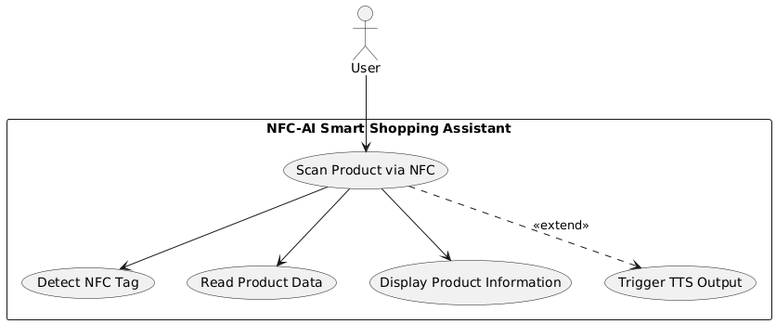
Use Case Diagram — Scan Product via NFC
Use Case Diagram — Get Product Recommendations
This diagram illustrates how the user interacts with the system to scan NFC tags and retrieve product information. The system responds by detecting the NFC tag, reading the product data, and displaying the information with text-to-speech support.
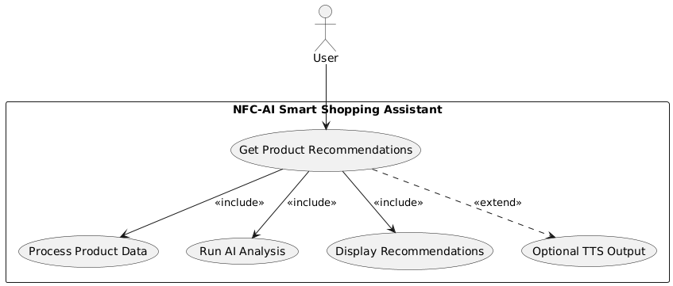

This diagram shows the interaction flow between the user and the AI recommendation module. After the product is scanned, the system processes the data, runs the AI engine, and displays or reads out recommended alternatives.

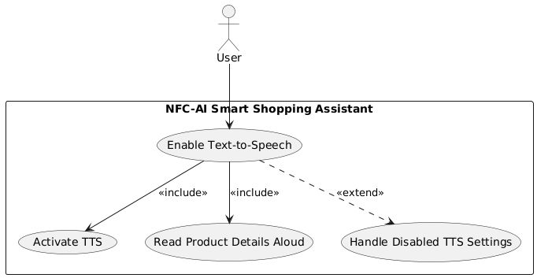
Use Case Diagram — Enable Text-to-Speech
This diagram illustrates how the user enables and interacts with the TTS accessibility feature. The system activates TTS and reads product details aloud, ensuring accessibility for visually impaired users.

CHAPTER 5: SYSTEM DESIGN

Sequence Diagram — Scan Product via NFC

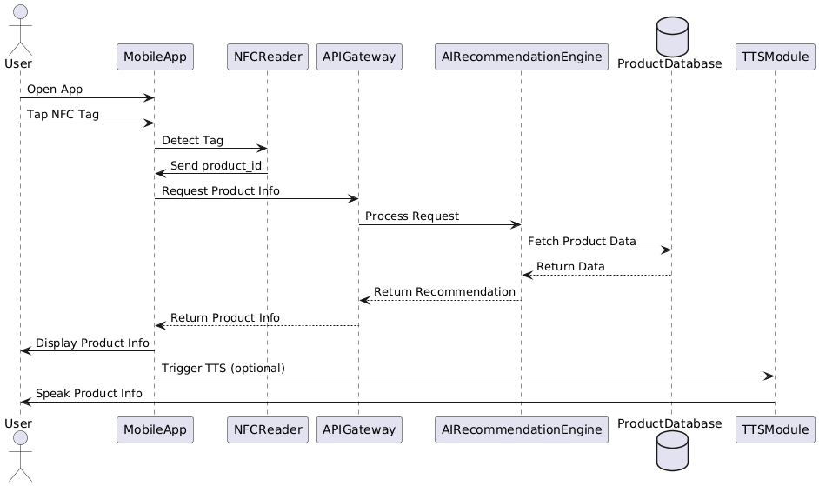

This diagram illustrates the interaction flow between the user and system components during the product scanning process. It shows how the MobileApp communicates with the NFCReader, APIGateway, AIRecommendationEngine, ProductDatabase, and TTSModule to retrieve and present product information. It also includes the optional step of triggering text-to-speech feedback for accessibility.

Class Diagram — NFC-AI Smart Shopping Assistant

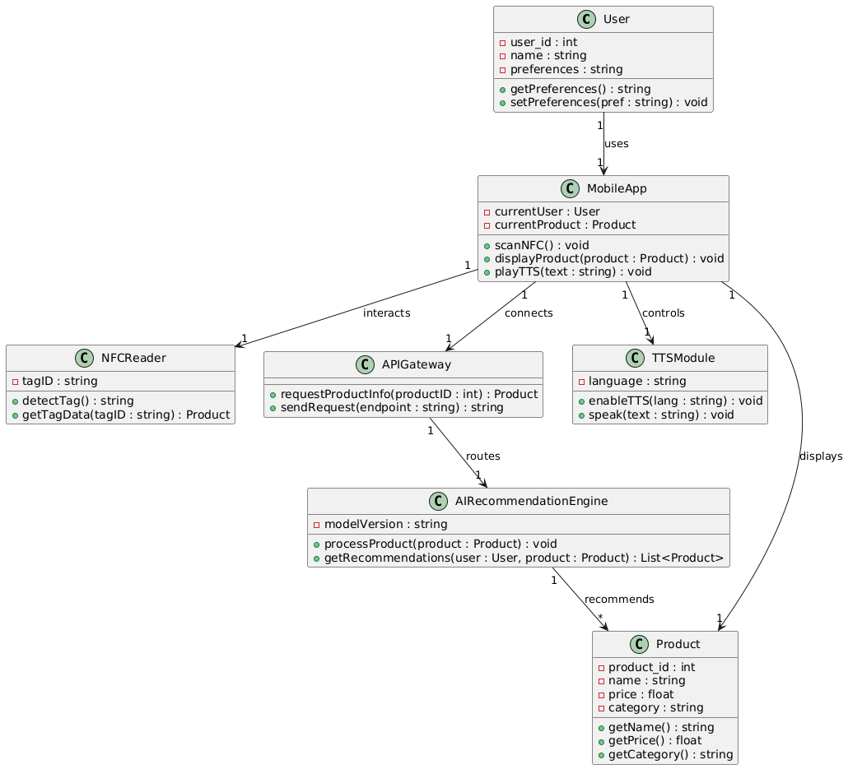

This diagram provides a detailed view of the system’s object-oriented structure. It includes all major classes, their attributes with data types, method signatures, access modifiers, and the relationships between them. The diagram shows how the MobileApp interacts with the NFCReader, APIGateway, AIRecommendationEngine, TTSModule, and Product classes, while the User class represents the end user’s profile and preferences. This level of detail supports the development phase by clearly defining system components, their responsibilities, and how they interact.

Entity-Relationship Diagram (ERD)

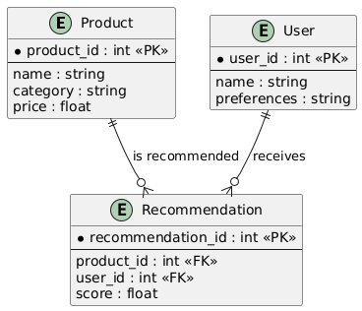

This diagram depicts the data model and relationships between core entities: User, Product, and Recommendation. It shows how users receive recommended products based on NFC scans and AI recommendations. Primary and foreign keys are clearly defined to ensure data integrity and support the database structure used by the system.

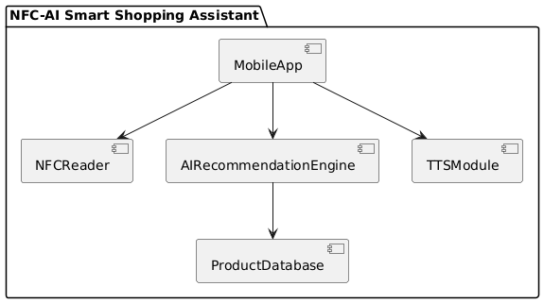
Component Diagram — System Modules
The component diagram describes the high-level structure of the system’s modules and their dependencies. It outlines how the MobileApp interacts with functional components including NFCReader, AIRecommendationEngine, TTSModule, and the ProductDatabase. This view helps clarify how the software is decomposed into functional parts.

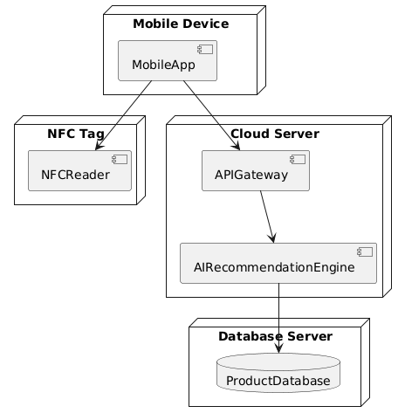
Deployment Diagram — System Architecture
The deployment diagram provides a physical view of how the system is deployed across devices and servers. It shows how the MobileApp on the user’s device communicates with the NFCReader, APIGateway and AIRecommendationEngine hosted on the cloud, and the ProductDatabase stored on the server. This model ensures clarity regarding networked components and infrastructure setup.

CHAPTER 6: DISCUSSION & CONCLUSION

  - Discussion
Throughout Senior Project I, we reviewed each stage of the system’s development and evaluated several possible directions for how the NFC-AI Shopping Assistant could be designed. During this reflection, we examined alternative features and architectural choices that initially appeared promising but were ultimately refined to keep the project realistic and aligned with the goals of this phase. This process strengthened the clarity of the system requirements and ensured that the project remained achievable within the limits of time, hardware, and academic scope.
One of the alternatives we explored was expanding the system with additional accessibility modes—such as barcode scanning, voice-controlled navigation, or image-based product recognition. While useful, these additions would require extra sensors, heavier computation, or more complex data pipelines, which would shift focus away from the core purpose of integrating NFC, AI recommendations, and text-to-speech support. Prioritizing NFC as the primary interaction method allowed us to maintain simplicity, reduce processing overhead, and ensure a consistent experience for visually impaired users, who benefit from the precision and reliability of NFC tags compared to camera-based features.
Another major alternative was the possibility of implementing the AI recommendation model fully on the mobile device. This direction was appealing because it would allow offline functionality and improved privacy. However, after analyzing storage requirements, model size, and the computational limitations of typical smartphones, we concluded that a cloud-based AI engine would be the most practical choice for now. This approach reduces device load, keeps model updates centralized, and enables more accurate recommendations without overwhelming local hardware. On-device AI remains a strong candidate for future work as mobile processors and optimization tools continue to evolve.
We also considered integrating broader IoT interactions, such as syncing product data with smart refrigerators or home inventory systems. While these ideas demonstrate the long-term potential of the system, they were excluded from the current phase to avoid scope expansion and ensure that Senior Project I focused on producing solid analysis and complete design documentation.
By reflecting on these alternatives and justifying our choices, we established a focused and feasible foundation for the system. This balanced approach ensures that the core features—NFC scanning, AI-powered recommendations, and accessibility through text-to-speech—are supported by a clear architecture and a realistic implementation plan for Senior Project II

  - Conclusion

This project established the conceptual and architectural foundation for an intelligent shopping assistant that combines NFC technology, AI-driven product recommendations, and text-to-speech accessibility. Through research and analysis conducted in Senior Project I, we identified the value of integrating these technologies to support visually impaired and health-conscious users in real shopping environments. The chapters in this report collectively clarified the problem, documented user needs, defined functional and non-functional requirements, and produced the models necessary to guide future development.
During this phase, we evaluated several potential design directions—such as expanding accessibility through barcode scanning or image recognition, enabling offline on-device AI processing, and incorporating additional IoT integrations. While these features presented exciting opportunities, they were not adopted at this stage due to limitations in hardware capabilities, system complexity, and the scope of Senior Project I. Focusing on NFC-based interaction, cloud-powered AI, and streamlined accessibility features allowed us to create a practical and technically grounded design that can be realistically implemented in the next phase.
Overall, Senior Project I enabled us to explore the technical landscape, refine our system approach, and make informed decisions about which features belong in the current scope and which should be reserved for future enhancement. The insights gained throughout this stage provide a solid foundation for Senior Project II, where we will shift toward full implementation, integration, and testing of the NFC-AI Shopping Assistant. Future work may include exploring offline machine-learning models, expanding accessibility modes, enhancing personalization, and integrating the system with broader IoT ecosystems as technology and hardware capabilities evolve.

REFERENCES
1. Villegas-Ch., W., García, J., & Medina, E. (2023). Design proposal for a virtual shopping assistant for people with vision problems applying AI techniques. Informatics, 7(2), 96. https://www.mdpi.com/2504-2289/7/2/96
2. Kamikubo, R., Saito, H., & Kobayashi, Y. (2024). Supporting blind people in recreational window shopping. Proceedings of the ACM on Interactive, Mobile, Wearable and Ubiquitous Technologies, 8(3). https://dl.acm.org/doi/full/10.1145/3677846.3677860
3. de Grave, R. B., Hermans, R., & Vissers, J. (2024). Smartphone apps for food purchase choices: A scoping review. International Journal of Behavioral Nutrition and Physical Activity, 21(1), 14. https://pmc.ncbi.nlm.nih.gov/articles/PMC10955402/
4. Letaifa, H., Allouche, Y., & Khemaja, M. (2023). “Tell me why”: Using natural-language justifications in nutrition recommenders. User Modeling and User-Adapted Interaction, 33(3), 541–568. https://link.springer.com/article/10.1007/s11257-023-09377-8
5. Calahorra-Candao, G., Martínez, M., & Hernández, A. (2024). From typing to talking: AI’s role in voice shopping. Information, 15(4), 202. https://www.mdpi.com/2078-2489/15/4/202
6. Mo, L., Kim, S., & Park, J. (2024). Unlock happy interactions: Voice assistants and consumer outcomes. Journal of Theoretical and Applied Electronic Commerce Research, 19(2), 53–69. https://www.mdpi.com/0718-1876/19/2/53
7. Borowski-Beszta, M. (2024). Digital payment services as assistive technology for people with disabilities. Disability & Society, 39(5), 786–805. https://www.tandfonline.com/doi/abs/10.1080/09687599.2023.2254468
8. Rostami, M., Shokouhyar, S., & Hasani, S. (2023). A novel healthy and time-aware food recommender system. Expert Systems with Applications, 221, 119825. https://www.sciencedirect.com/science/article/pii/S0957417423002208
9. Lavric, A., Filip, I., & Popa, C. (2024). Survey: Emerging assistive technologies for the visually impaired. Sensors, 24(15), 4834. https://www.mdpi.com/1424-8220/24/15/4834
10. Yu, W. W., Wong, L., & Chau, K. (2023). The role of NFC mobile payments in restaurant operations. Sustainability, 15(16), 12471. https://www.mdpi.com/2071-1050/15/16/12471
11. Filippini, C., Rossi, M., & Tan, Z. (2024). Technology aid for blindness and low vision. Sensors, 24(14), 4453. https://www.mdpi.com/1424-8220/24/14/4453
12. Žurbi, T., Novak, D., & Knez, M. (2024). NFC tag awareness and visual implementation on packaging. Applied Sciences, 14(21), 9933. https://www.mdpi.com/2076-3417/14/21/9933
13. Rais, R. N. B., Khan, M., & Laghari, A. (2024). Hybrid group-based food recommenders. Applied Sciences, 14(13), 5843. https://www.mdpi.com/2076-3417/14/13/5843
14. López-Barreiro, J., Pérez, L., & Ortega, F. (2024). AI-powered recommender systems for health. Applied Sciences, 14(22), 10220. https://www.mdpi.com/2076-3417/14/22/10220
15. Prandi, C., Monti, L., & Ceccarini, C. (2023). Accessible wayfinding and navigation: A systematic review. Universal Access in the Information Society, 22(3), 445–461. https://link.springer.com/article/10.1007/s10209-021-00843-x
16. Zhang, H., Li, X., & Zhou, Y. (2025). Research on the application of NFC. Proceedings of the ACM on Computing and Sustainable Societies, 8(2). https://dl.acm.org/doi/10.1145/3726010.3726068
17. Liu, M., Chen, Y., & Wang, H. (2025). Blind-guiding and shopping assistance robot for markets. Sensors, 25(12), 3785. https://www.mdpi.com/1424-8220/25/12/3785
18. Messi, L., Ferrari, M., & Bianchi, P. (2025). Audio AR navigation for blind and visually impaired people. Buildings, 15(18), 3252. https://www.mdpi.com/2075-5309/15/18/3252
19. Jakob, D., Krüger, J., & Stein, T. (2025). Adapting voice assistants for older adults. AI, 5(1), 4. https://www.mdpi.com/2673-6470/5/1/4
20. Pires, R., Gomes, D., & Silva, P. (2024). Optimizing supermarket shopping simulation using NFC: An inclusive approach for people with disabilities. International Conference on Inclusive Smart Retail Technologies. https://www.researchgate.net/publication/388952488_Optimizing_Supermarket_Shopping_Simulation_Using_NFC_An_Inclusive_Approach_for_People_with_Disabilities
21. Lee, J., Choi, S., & Kim, Y. (2025). DietQA: A personalized diet question-answering and recommender framework. Computers, 14(10), 412. https://www.mdpi.com/2073-431X/14/10/412
22. Zioutos, K., Papadopoulos, N., & Georgiou, A. (2023). Healthy personalized recipe recommendations. Computers, 13(1), 1. https://www.mdpi.com/2073-431X/13/1/1
23. Jansen, L. Z. H., Meyer, K., & Scholz, T. (2025). Personalized value-based justifications in healthy food swaps. Electronic Markets, 35(2), 299–315. https://link.springer.com/article/10.1007/s10660-025-09961-7
24. Bourg, L., Martin, J., & Fabre, P. (2023). Enhancing shopping experiences in smart retailing (SMARTBUY). Journal of Ambient Intelligence and Humanized Computing, 14(5), 4765–4779. https://link.springer.com/article/10.1007/s12652-020-02774-6
25. Onumadu, P., Adewale, F., & Okechukwu, C. (2024). NFC cyber threats and mitigations. Sensors, 24(23), 7423. https://www.mdpi.com/1424-8220/24/23/7423

APPENDIX: Glossary
AI (Artificial Intelligence)
Technology that enables software to analyze data and make recommendations.
API (Application Programming Interface)
A set of rules allowing different software systems to communicate.
Accessibility
Design features that help users with disabilities use the system effectively.
Alternative Recommendation
A healthier or allergen-safe product option suggested by the AI module.
Cloud Database
Online storage for product information accessed over the internet.
Database (Local)
On-device storage used to quickly retrieve product details.
ERD (Entity-Relationship Diagram)
A diagram showing system data entities and their relationships.
Functional Requirements (FR)
What the system must do (e.g., NFC scanning, TTS output).
NFC (Near Field Communication)
Short-range wireless technology used to read product tags.
NFC Tag
A small chip on products containing encoded product data.
Nonfunctional Requirements (NFR)
System qualities such as performance, security, and usability.
Product Database
A structured dataset containing product names, ingredients, allergens, etc.
Product Information Retrieval
The process of reading an NFC tag and fetching its data.
SRS (Software Requirements Specification)
A formal document describing system requirements and design.
Sprint
A time-boxed cycle in Agile development focused on specific tasks.
TTS (Text-to-Speech)
Technology that converts text into spoken audio.
UI (User Interface)
Screens and controls the user interacts with.
UML (Unified Modeling Language)
Standard diagrams used to model system structure and behavior.
Use Case
A description of how a user interacts with the system.
Visually Impaired User
A user with limited or no ability to read visual text.

